1. Create the meeting room + invite students and censor
(The same meeting room can be used the whole day and every day)

Web:  https://ucph-ku.zoom.us | App:  Sign In: ucph-ku.zoom.us | Outlook:
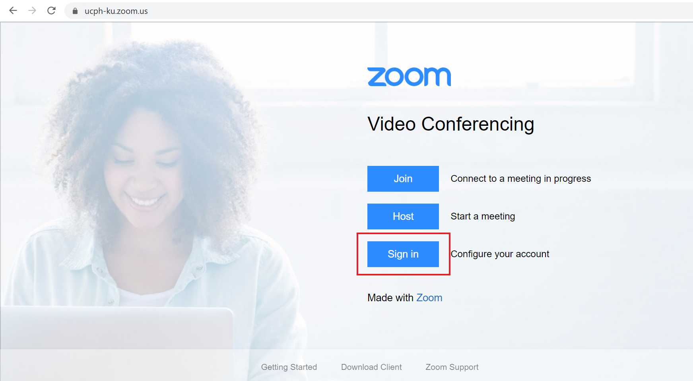“Sign In” (swedish license plate) | 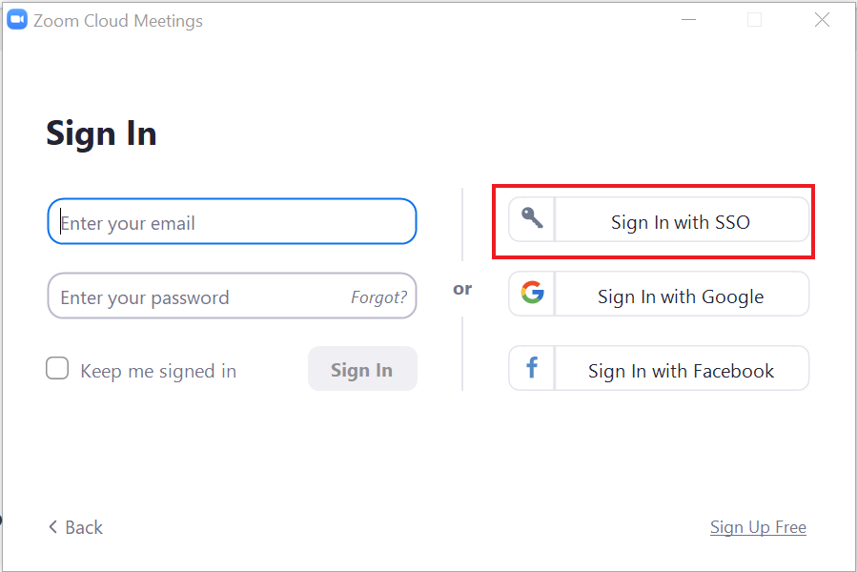  “Sign In” (swedish license plate)
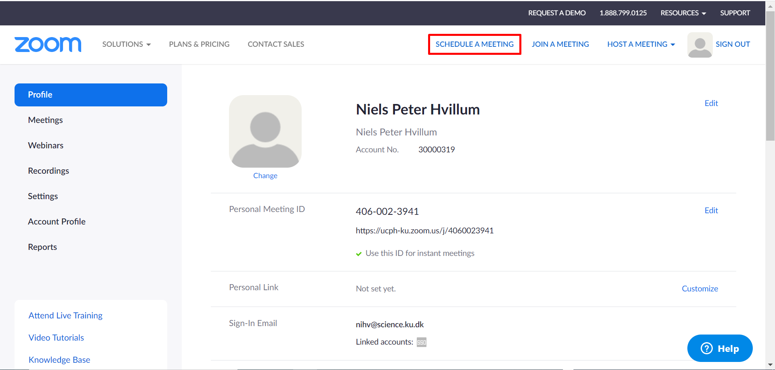  “Schedule a meeting” | 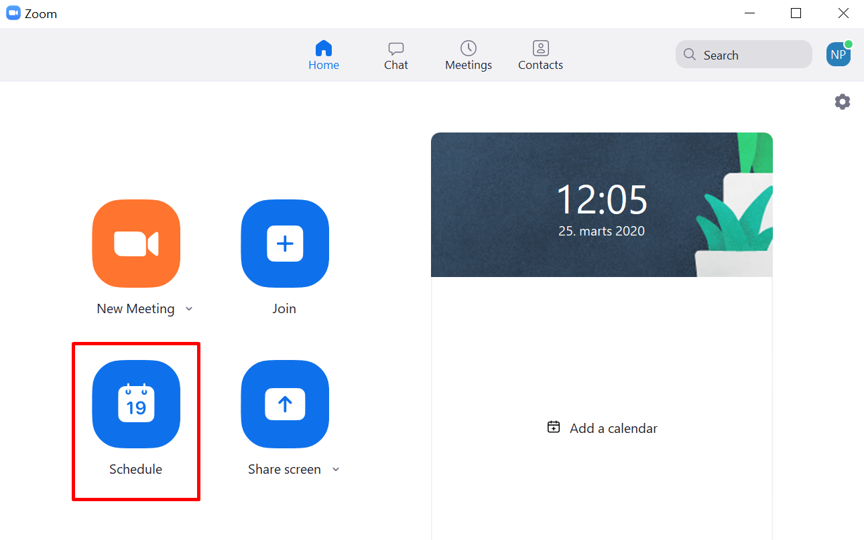  “Schedule” | 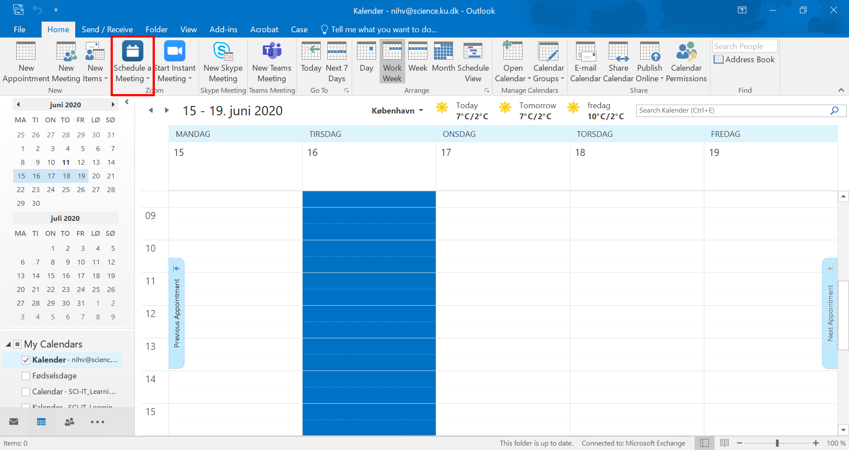  “Schedule a meeting”
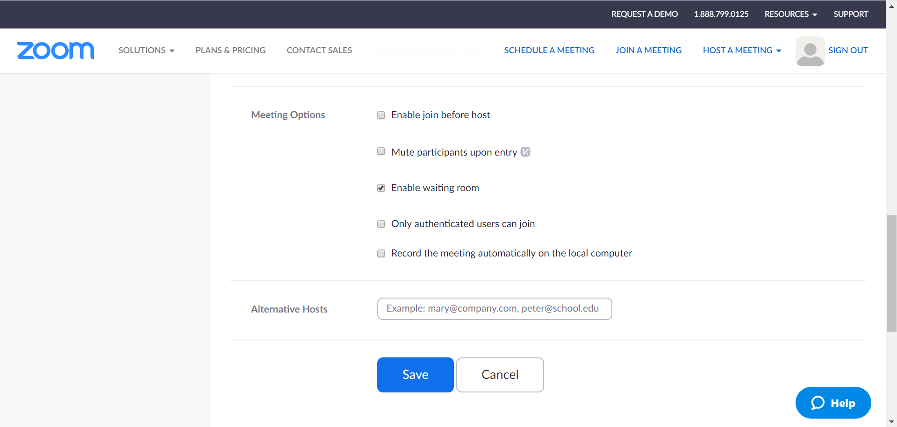  Meeting options:  - Unmark ‘Enable join before host’  - Mark ‘Enable waiting room’  - Invite censor as an ‘Alternative host’ | 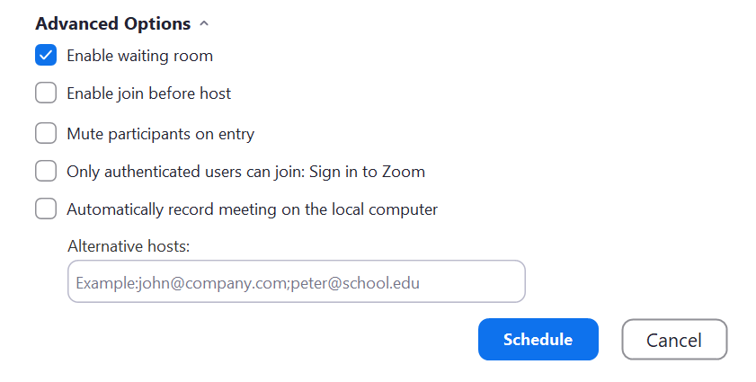  Advanced options:  - Mark ‘Enable waiting room’  - Unmark ‘Enable join before host’  - Invite censor as an ‘Alternative host’ | 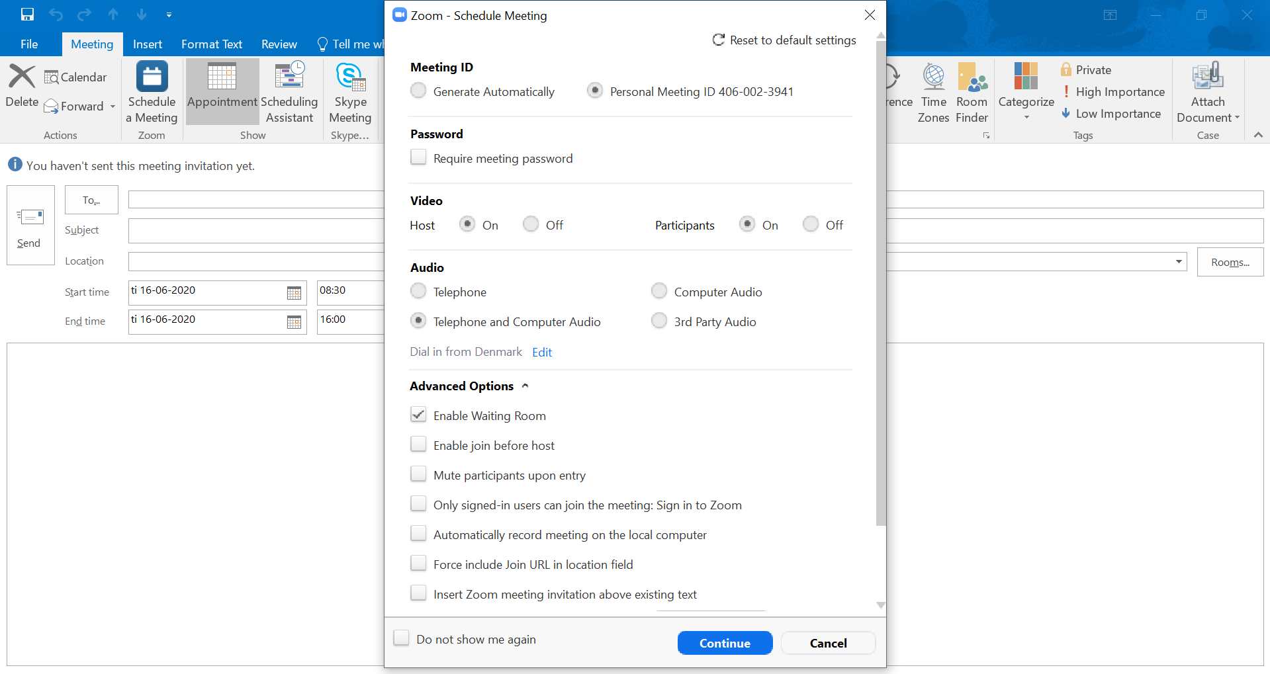  Advanced options:  - Mark ‘Enable waiting room’  - Unmark ‘Enable join before host’  - Invite censor as an ‘Alternative host’
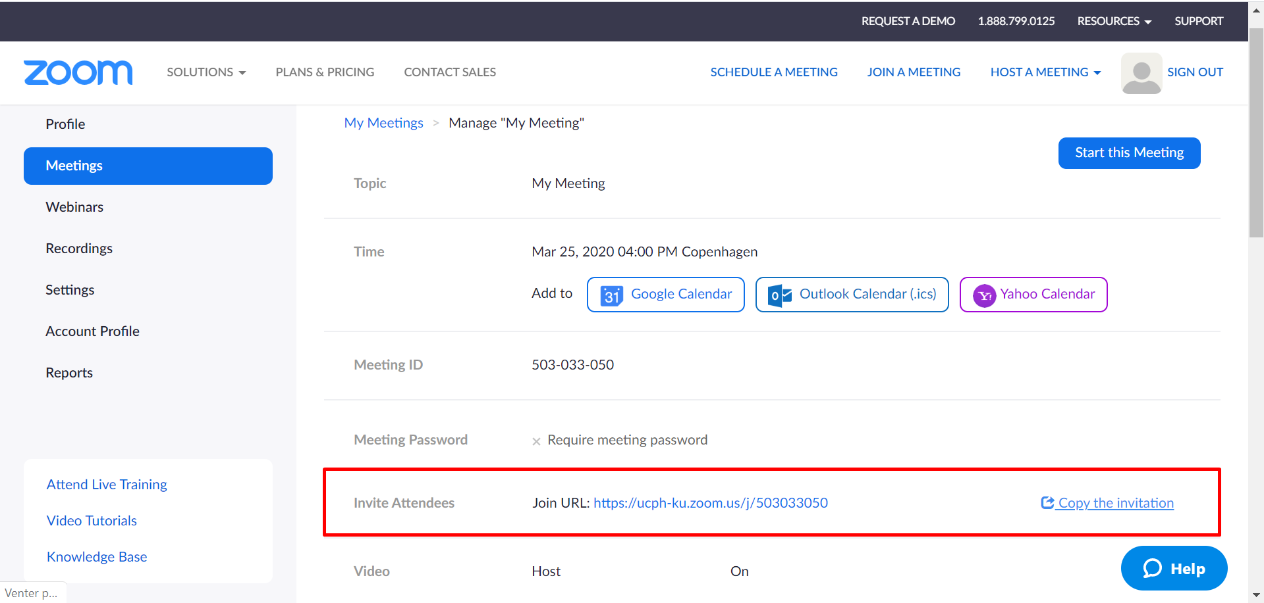  “Invite attendees” (students) with the link | 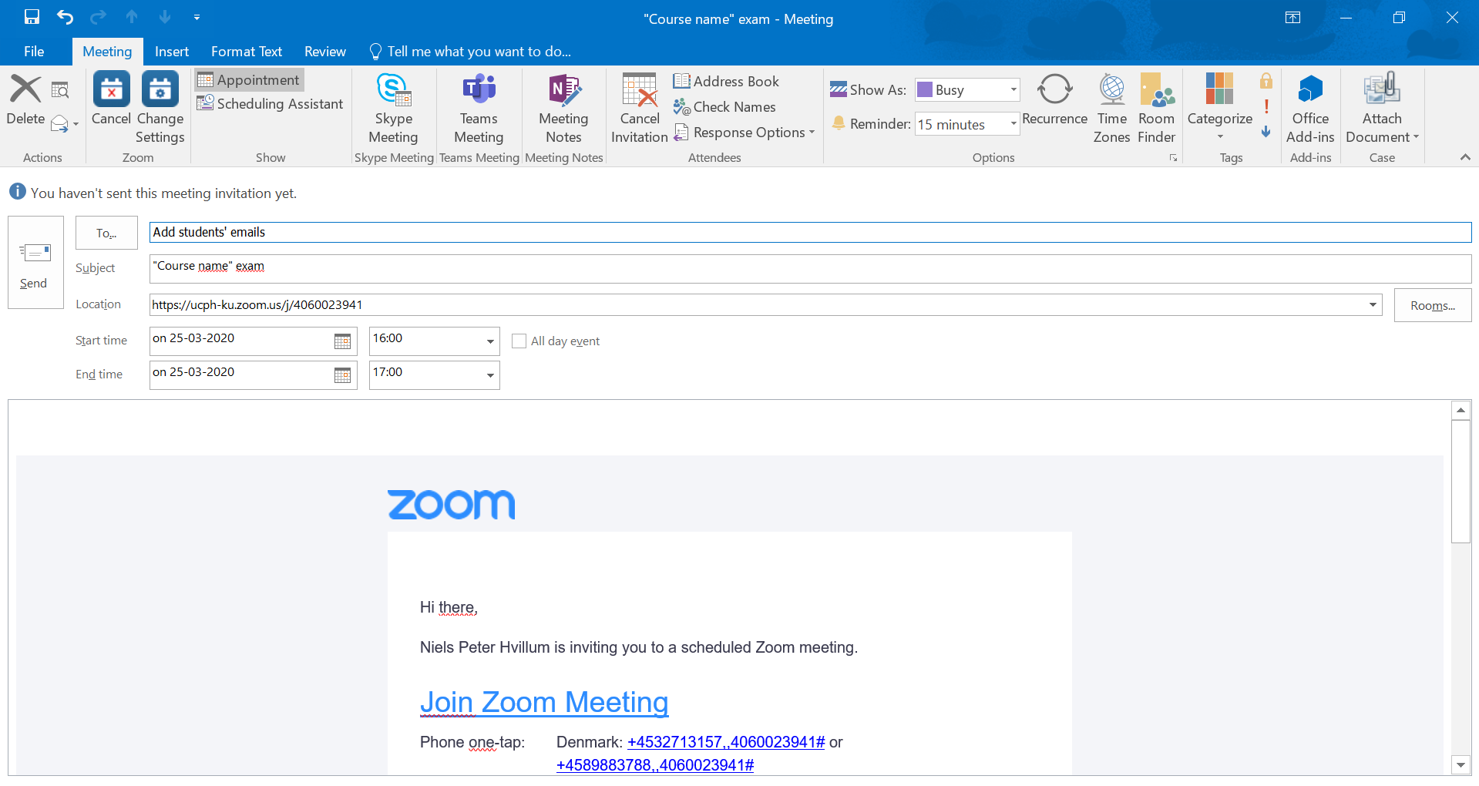  Invite students via email and add a name | 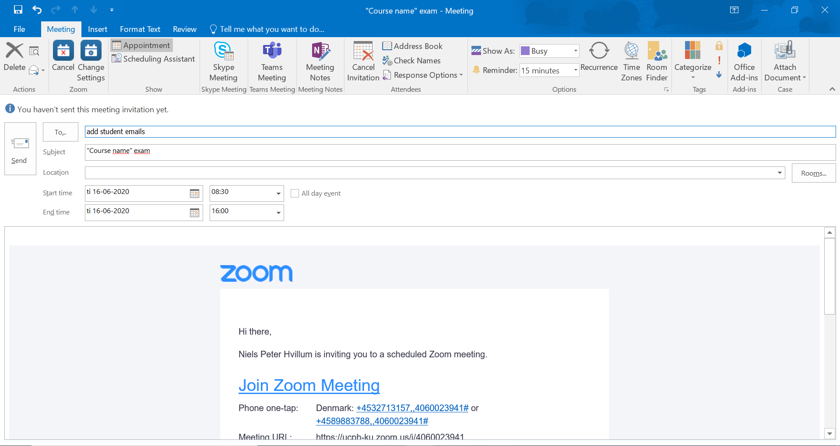  Invite students via email and add a name

2. Open the meeting room: Click the ‘Join Zoom Meeting’-link and ‘Open Zoom’ in your browser

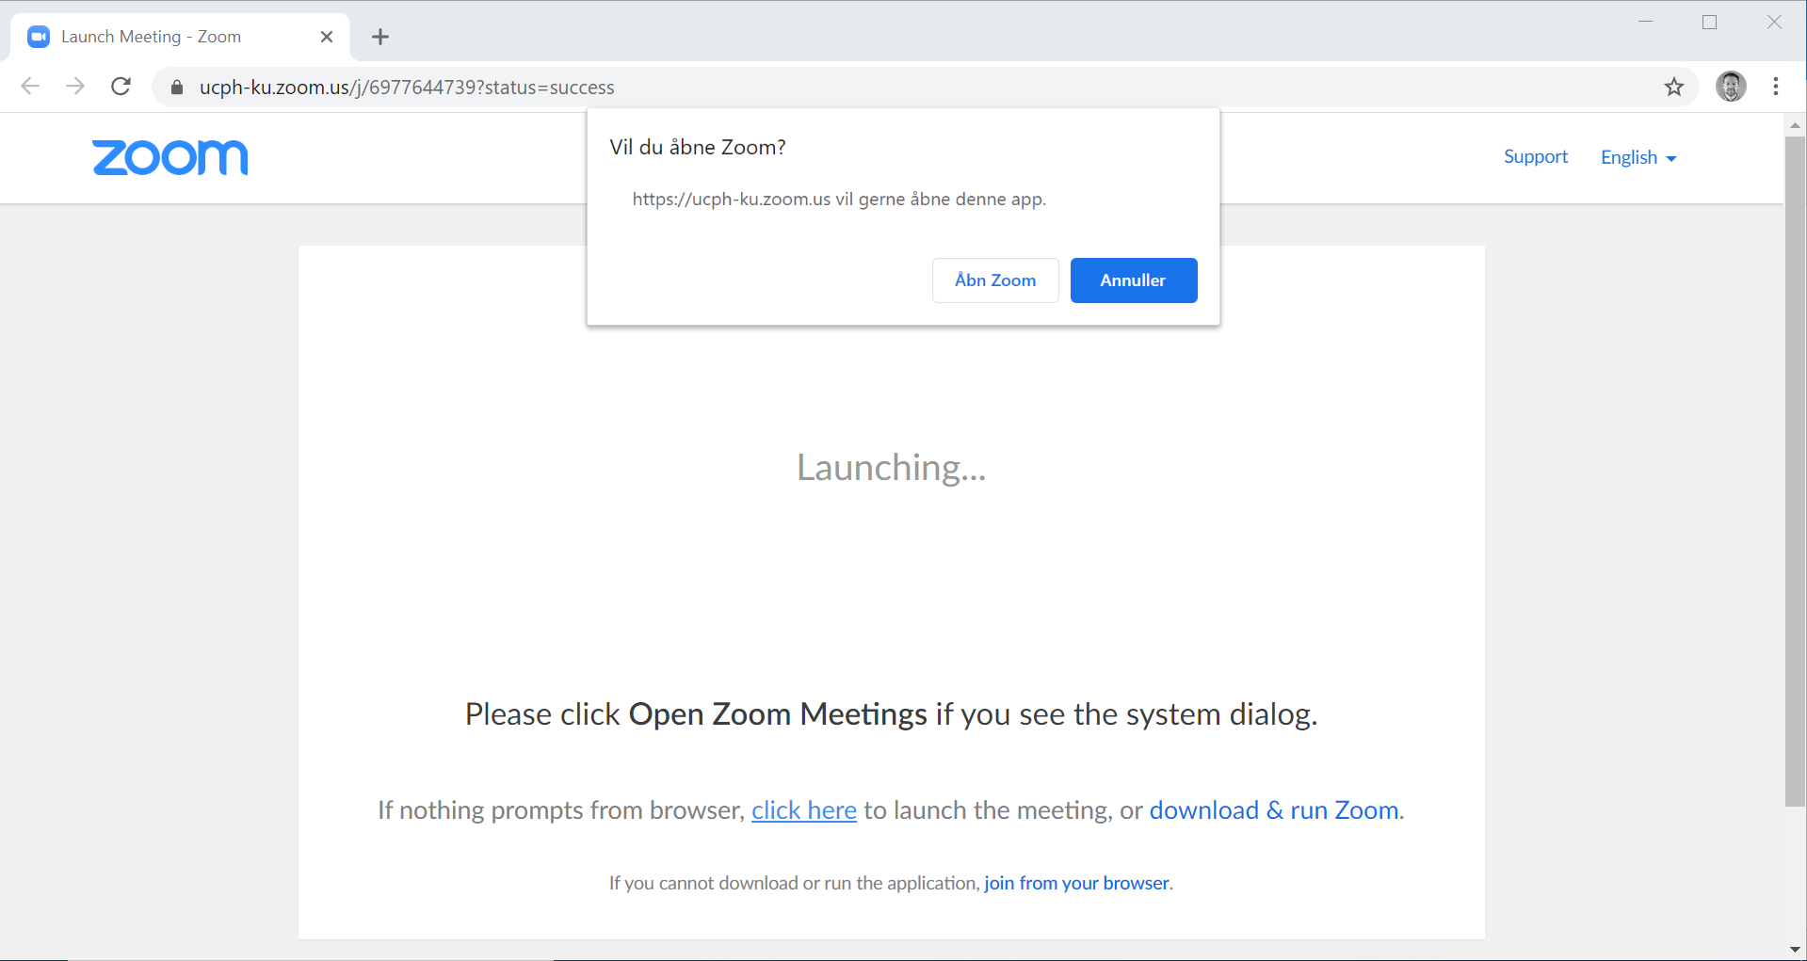
3. ‘Test Speaker and Microphone’, then ‘Join with Computer Audio and ‘Start Video’

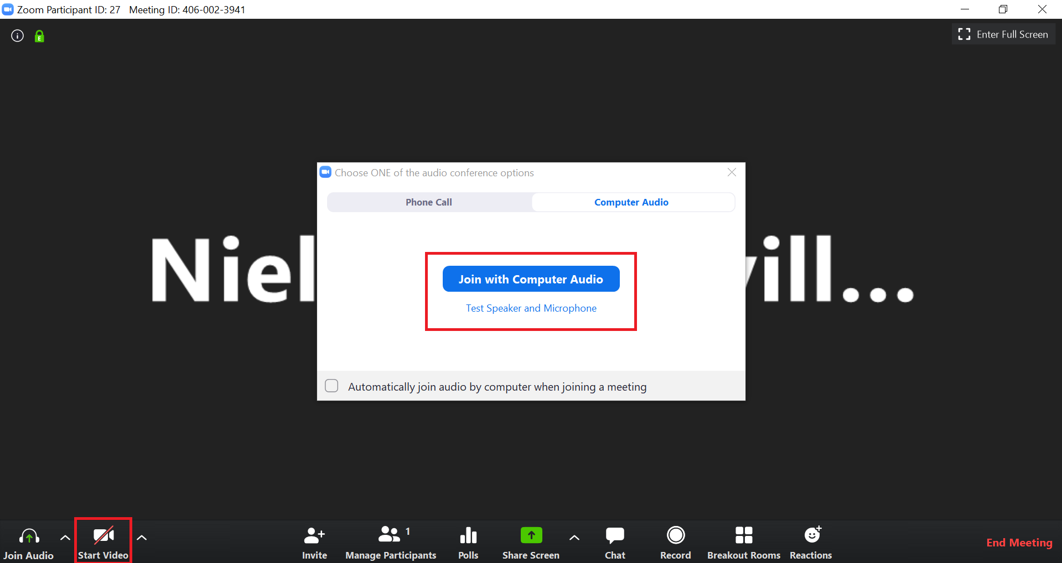
4. Admit a student from the waiting room: Move cursor to the student and click ‘Admit’

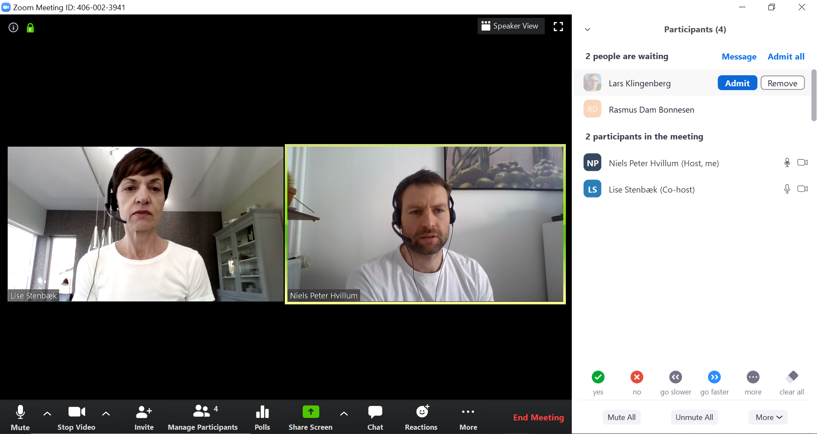

5. The student can present: The student clicks ‘Share Screen’ and selects the presentation window

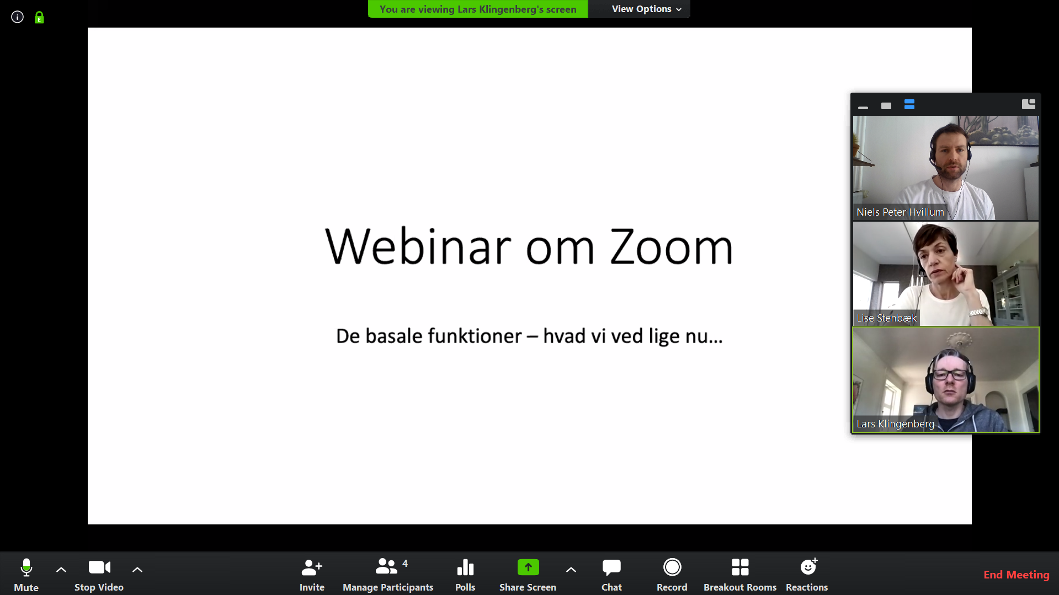
6. Send the student to the waiting room: Move cursor to the student and click ‘More’ and ‘Put in Waiting Room’

